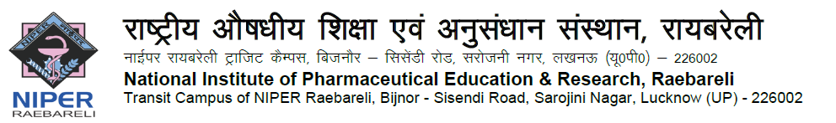

APPLICATION FOR THE POSITION OF “PROFESSOR OF PRACTICE”

- GENERAL INFORMATION: (In BLOCK Letters)
NAME |  | Paste recent passport size color photograph
GENDER
DATE OF BIRTH
CONTACT NO.
CONTACT MAIL ID
NOMINATION
(SELF / BY EXPERT)

- EDUCATIONAL QUALIFICATIONS: (Add columns if required)
Degree | School/College/Institute | Board/University | Subject | %/CGPA/CPI | PASSING YEAR
Bachelor Degree or equivalent
Post Graduation or equivalent
Ph.D DETAILS
Thesis Title | Supervisor Name | Institute | Registration Date | Submission Date | Award Date

- DETAILS OF EXPERIENCE: (Add columns if required)
ORGANIZATION /INSTITUTE | POSITION HELD | TYPE OF WORK | START DATE | END DATE | ANNUAL CTC/PRESENT PAY
- RESEARCH & DEVELOPMENT: (Add columns if required)

Total No. of PG Projects Guided |  |  |  |  |  |  | Total No. of Patents
Number of PhD Thesis Guided
Supervisor |  |  |  |  | Co-Supervisor
Completed | Submitted |  |  | On-going | Completed |  |  |  | Submitted |  |  | On-going
Number of Projects
PI |  |  |  |  |  | Co-PI
Completed | On-going |  | Consultancy |  |  | Completed |  | On-going |  |  | Consultancy

Publication
Name of the journal | Title of the research paper | Latest Impact Factor | Volume | Year of Publication | Author

In Journals(Referred) |  |  | Book Published/Book Chapter |  |  | Technical Reports
National | International
In Conferences
Referred |  |  |  | Un-Referred
National |  | International |  | National | International

Awards & Achievements
Total No. of Awards |  | Remarks
Total No. of Achievements |  | Remarks

- NOMINATION DETAILS
(to be filled only by applicants nominated by an Expert)

NAME OF THE EXPERT
CURRENT DESIGNATION
ORGANIZATION / INSTITUTE
CONTACT MOBILE No.
CONTACT MAIL ID

- REFEREE/REFERENCES:

Sl. No. | NAME & DESIGNATION | ORGANIZATION | E-MAIL – ID | CONTACT NO
01.
02.
03.

DECLARATION

I hereby declare that I have read and understood the instructions and particulars supplied to me and that all the entries in this form are true to the best of my knowledge and belief. If selected for interview, I promise to abide by the rules and regulations of the Institute. I also understand that I shall have to produce originals and self-attested copies of all supporting documents at the time of interview.

Date: Signature
Name:

